# BI TOOL

## 1 introduction

Business intelligence (BI) is a set of theories, methodologies, architectures, and technologies that transform raw data into meaningful and useful information for business purposes.

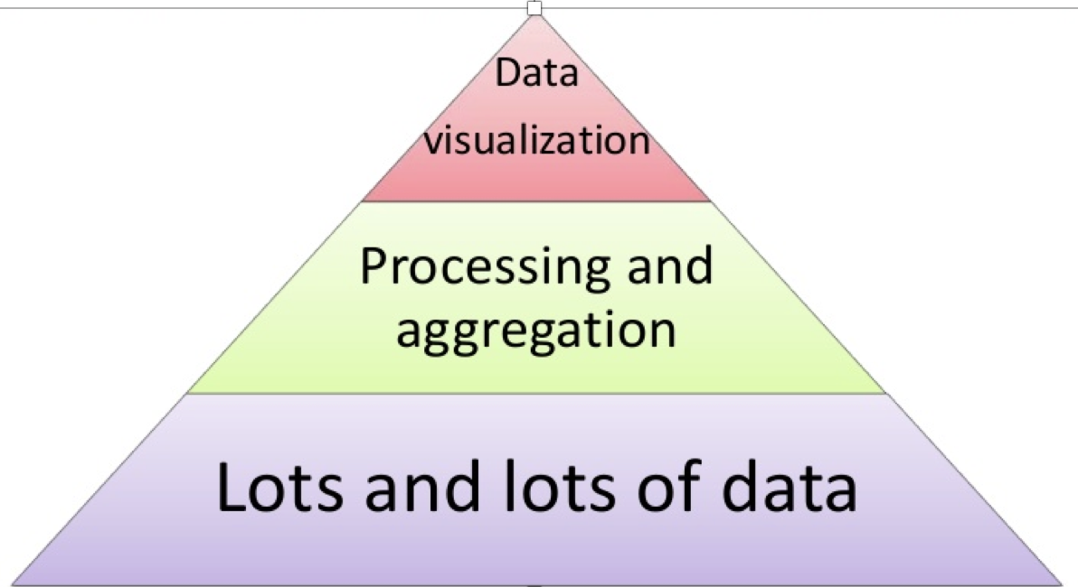

Gartner **is the world's leading information technology research and advisory company.**

“We deliver the technology-related insight necessary for our clients to make the right decisions, every day***”***

## 2. comparison business tool



SAP BusinessObjects BI (also known as BO or BOBJ) is a suite of front-end applications that allow business users to view, sort and analyze business intelligence data.

## Strengths

Massive resources

SAP not only has the financial resources, but also the technical resources to go through development cycles and improve their products as necessary. And due to its overwhelming adoption rates, you’ll never have trouble finding a developer skilled in Business Objects’ proprietary language.

Nearly Endless Scalability

Business Objects can handle the task and scale as your organization grows. Hands down, scalability is one of the primary reasons large corporations choose Business Objects for their BI needs.

Robust Feature Set

Versatile Integration Business Objects can connect to a variety data sources such as OLAP, and XML. It can also connect to any number of integration points like SharePoint, Java, Microsoft Office and .NET.

Solid Administrative and Data Governances Many software vendors are able to integrate their security models with the Business Object API to provide data level security as well.

## Weakness

Quite Expensive

Require number of servers

Upgrading is difficulty

Not business user friendly

High-pressure sales and poor support



Qlik is a [software](https://en.wikipedia.org/wiki/Software) company based in [Radnor, Pennsylvania](https://en.wikipedia.org/wiki/Radnor,_Pennsylvania), United States. Qlik is the provider of QlikView and Qlik Sense, [business intelligence](https://en.wikipedia.org/wiki/Business_intelligence) & [visualization software](https://en.wikipedia.org/wiki/Visualization_software).

## strengths

The service runs on its own platform using **in-memory technology**. This lessens the program's dependency on IT professionals to regularly maintain and manage the system, thus reducing maintenance costs

**Customer experience** is one of the biggest strenghs of Qlikview, making the adoption of the platform really smooth to the user, both the final user and the power user who could have a more active developer role.

Qlikview works in memory, so unlike other BI systems, **Qlikview focuses on speed**, and users can locate and gather information on on the system faster than with other available platforms. To have an **associative database** instead of a relational one also helps to get quicker.

Qlikview **provides business heads** with a clear snapshot of the company so they can deal with problems even before these affect the company.

Qlikview allows **in-house and multi-location correspondence**, so that company heads have access to the same data and can correspond accordingly with each other.

## Weakness

Qlikview is designed for fast collection of required business data. However, this makes the system **hardware-dependent**. Without an advanced hardware system to support it, its use might prove to be inconvenient.

in the most part of cases it will **replicate data** in its associative database.

Though the program promises certain independence from IT professionals, most companies will still need **IT support** for the program's installation and implementation.



Tableau Software is a software company headquartered in Seattle, Washington, United States which produces interactive data visualization products focused on business intelligence.

## Strengths

Its **versatility**, both in terms of deployment options across cloud and on-premises as well as the use cases it can be deployed against.

**Easy of use** and easy to learn about it.

Tableau's core product strengths continue to be its **diverse range of data source connectivity**, which is constantly expanding, as well as its interactive visualization and exploration capabilities.

## Weakness

It doesn't have a very interesting enterprise **pricing model**.

Tableau requires separate **ETL tool**.

**Weaknesses in the area of data integration** across data sources. Tableau supports a diverse range of data connectivity options — spanning relational, online analytical processing (OLAP), Hadoop, NoSQL and cloud sources — but offers little support when it comes to integrating combinations of these sources in preparation for analysis.

The most experienced users complain Tableau is **lacking in advanced features** and more sophisticated capabilities such as embedded BI, data preparation and metadata management.

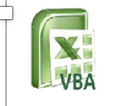

By Vangie Beal Abbreviated as **VBA**, **Visual Basic for Applications** is a programming language that is similar to **Visual Basic**, only it is embedded in an individual Microsoft **application** such as Excel or Access. Using **VBA** you can create macros or small programs that perform tasks within the Microsoft**application**.

## Strengths

The structure of the [Basic programming language](http://en.wikipedia.org/wiki/BASIC) is very simple, particularly as to the executable code.

VB is not only a language but primarily an integrated, interactive development environment (“[IDE](http://en.wikipedia.org/wiki/Integrated_development_environment)“).

The VB-IDE has been highly optimized to support rapid application development (“RAD”). It is particularly easy to develop [graphical user interfaces](http://en.wikipedia.org/wiki/Graphical_user_interface) and to connect them to handler functions provided by the application.

The graphical user interface of the VB-IDE provides intuitively appealing views for the management of the program structure in the large and the various types of entities (classes, modules, procedures, forms, …).

VB provides a comprehensive interactive and context-sensitive online help system.

When editing program texts the “[IntelliSense](http://en.wikipedia.org/wiki/IntelliSense)” technology informs you in a little popup window about the types of constructs that may be entered at the current cursor location.

VB is a component integration language which is attuned to Microsoft’s Component Object Model (“COM”).

COM components can be written in different languages and then inegrated using VB.

Interfaces of COM components can be easily called remotely via Distributed COM (“DCOM”), which makes it easy to construct distributed applications.

COM components can be embedded in / linked to your application’s user interface and also in/to stored documents ([Object Linking and Embedding](http://en.wikipedia.org/wiki/Object_Linking_and_Embedding) “OLE”, “Compound Documents”).

There is a wealth of readily available COM components for many different purposes.

Visual Basic is built around the .NET environment used by all Microsoft Visual languages, so there is very little that can’t be done in Visual Basic that can be done in other languages (such as C#).

## Weakness

Visual basic is a proprietary programming language written by Microsoft, so programs written in Visual basic cannot, easily, be transferred to other operating systems.

There are some, fairly minor disadvantages compared with C. C has better declaration of arrays – its possible to initialise an array of structures in C at declaration time; this is impossible in VB.



Talend is a software integration vendor. The company provides big data, cloud storage, data integration, data management, master data management, data quality, data preparation and enterprise application integration software and services.

## Strengths

Numerous connectors helps to develop application business logic under one roof

Continuous integration reduces overhead of repository management and deployment

Free open source

Java notion is good enough

## Weakness

Numerous connectors helps to develop application business logic under one roof

Continuous integration reduces overhead of repository management and deployment



MicroStrategy, Inc. is a provider of business intelligence, mobile software, and cloud-based services. The company is based in the Washington, D.C. area and serves companies and organizations worldwide.

## Strength

**Schema & SQL Engine** – This is MicroStrategy’s bread and butter in my opinion.  You provide a relational [snowflake](http://en.wikipedia.org/wiki/Snowflake_schema) data model and it will glide right over it, giving you an easy drag and drop semantic layer to build your reports.  Enterprises love it because this is the start of Self Service, where business users don’t need to know complex definitions or code but can craft reports and drill freely.  IT loves it because they can ensure that logic stays in sharable objects and can be easily maintained.

**Emails** – If your users love formatted emailed reports, MicroStrategy has a great ability to send out what you see on the web in HTML or PDF form.

**Mobile** – I’m not a fan of Mobile BI.  I think the target use case is very niche and it’s just a fancy demo that doesn’t have longevity.  Jaded or not though, there’s no doubt that MicroStrategy has the premiere Mobile BI platform in the market.  I’ve seen some really amazing apps built on it, and without writing a single line of code.  If Mobile BI is your thing, it’s pretty hard not to love it.

**Scalability** – MicroStrategy has great SQL optimization for a very wide array of platforms which pushes the demand to the database.  In terms of scaling, it’s really more about database pressure than MicroStrategy pressure.  [Intelligent Cubes](http://www.bryanbrandow.com/2011/03/intelligent-cubes-dynamic-sourcing-vs-view-reports.html) are an option to cache very large amounts of data in your server’s memory if you do want to share the burden

## Weakness

**Development Environment** –  Developing on MicroStrategy has become very painful.  Development can be done in either a Desktop application that is a blast back to 1998 or a Web application that doesn’t have parity with Desktop and worse: many options that do exist in both are in different places with different styled UIs.  The Desktop application is still where you need to do your work but it’s so miserable to develop in that it irritates me to the point I don’t want to open it again.

**Community** – With no offense intended to anyone reading this, the MicroStrategy community is non-existent.  There are a few blogs out there with a couple of ideas (not counting mine, which is the best ;), but none that seem to last more than a couple of months.  There are a few people on the [forums](https://resource.microstrategy.com/Forum/) that diligently help out, but I haven’t posted to it in over 2 years and I’m still the all time contributor.  No one gives back and MicroStrategy doesn’t do anything to encourage a community or support those who do.



**SQL** (pronounced "ess-que-el") stands for Structured Query Language. ... **SQL**statements are used to perform tasks such as update data on a database, or retrieve data from a database. Some common relational database management systems that use **SQL** are: Oracle, Sybase, Microsoft **SQL Server**, Access, Ingres, etc.

## Strengths

Microsoft SQL Server is easier to use and has more features. Full support for triggers, for instance, are supported in Microsoft's product. MySQL introduced triggers recently, but they are not fully supported. The software offered by Microsoft also offers close integration with the .NET framework, which is not the case with competing products.

 Excellent Data Recovery Support

Corrupt data is always a concern when power loss or improper shutdowns occur. Microsoft SQL Server has a number of features that promote data restoration and recovery. Although individual tables can't be backed up or restored, complete database restoration options are available. Through the use of log files, caching, and backups, Microsoft's product allows you to feel confident that disaster recovery options are plentiful.

Self-Contained and Efficient

One major advantage of programs that are compiled is that they are self-contained units that are ready to be executed. Because they are already compiled into machine language binaries, there is no second application or package that the user has to keep up-to-date. If a program is compiled for Windows on an x86 architecture, the end user needs only a Windows operating system running on an x86 architecture. Additionally, a precompiled package can run faster than an interpreter compiling source code in real time.

Hardware Optimization

While being locked into a specific hardware package has its downsides, compiling a program can also increase its performance. Users can send specific options to compilers regarding the details of the hardware the program will be running on. This allows the compiler to create machine language code that makes the most efficient use of the specified hardware, as opposed to more generic code. This also allows advanced users to optimize a program's performance on their computers.

## Weakness

Cost

One of the major disadvantages to using Microsoft SQL Server instead of an alternative relational database management system is that the licensing options are pretty pricey. Although using the software for development or educational purposes is free, any sort of business use incurs a licensing fee. For SQL Server 2008, for instance, SQL Server Standard Edition costs $7,171 per processor. The SQL Server Datacenter edition is $54,990 per processor, according to the Microsoft website. For small businesses and individuals running for-profit websites, this is unaffordable. Competing software, such as MySQL, is often free for use. In cases where it is not, however, the most expensive MySQL Enterprise package costs $4,999 per server each year. This is significantly cheaper than even the Standard Edition Microsoft SQL package.

Hardware Optimization

While being locked into a specific hardware package has its downsides, compiling a program can also increase its performance. Users can send specific options to compilers regarding the details of the hardware the program will be running on. This allows the compiler to create machine language code that makes the most efficient use of the specified hardware, as opposed to more generic code. This also allows advanced users to optimize a program's performance on their computers.

Hardware Optimization

While being locked into a specific hardware package has its downsides, compiling a program can also increase its performance. Users can send specific options to compilers regarding the details of the hardware the program will be running on. This allows the compiler to create machine language code that makes the most efficient use of the specified hardware, as opposed to more generic code. This also allows advanced users to optimize a program's performance on their computers.

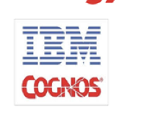

**Cognos** is **IBM's** business intelligence (BI) and performance management software suite. The software is designed to enable business users without technical knowledge to extract corporate data, analyze it and assemble reports.

## Strengths

Cognos is a Business Intelligence software suite from IBM. The software essentially comprises three segments: Analysis Studio, Query Studio and Report Studio.

The Analysis Studio can analyse large data sources and search for background information about an action or event. The component also offers multidimensional analysis that recognises trends with more insight than a standard report.

The Query Studio enables simple queries and self-service reports to answer simple business questions through a customisable report layout service. It has a variety of filtering and sorting functions, and allows formatting and the creation of diagrams as well.

* **Professional Authoring Mode** - offers Cognos’s complete range of capabilities, and allows the user to create any type of report. The user can work with any type of data, whether relational or multidimensional.
* **Express Mode** - provides a simpler interface for non-technical users. These users can create traditional reports with a more focused user interface. Unlike professional authoring mode, express authoring mode can display dynamic data.

## Weakness

**Initial Setup May Not Be Smooth**

For some of you, installing Cognos BI may not be much harder than what you need to do for other forms of high-end business software.

Others may not be so lucky and will find that you can’t just run the installer and turn it on. Instead, you’ll need to adjust your server setup before you can get it to run. Make sure your IT department has a chance to put a plan in place if this is necessary before you try to move forward with implementation.

**You Should Probably Use Internet Explorer**

Obviously, this business suite has a web portal. However, it can be a bit touchy about which browser you use. Most report that it’s most compatible with Internet Explorer. Browser change can challenge Cognos BI’s performance. If you use a browser like Mozilla, which tends to have fairly regular updates, you’ll most likely run into some touch-and-go problems with using this business suite.

**32-Bit Window Compatibility**

Another odd hiccup you’ll run into is with Windows. Framework Manager and other desktop tools were designed for 32-bit Windows. This was a strange choice considering 64-bit versions and other operating systems are available for the actual server.

Your best bet would be to consider your unique needs and then researching which business suites are preferred by companies in the same shoes. Still, even though there are definitely some cons to choosing Cognos BI, there’s no denying that it’s extremely popular for a reason.



Oracle BI is a business suite that is composed of leading technologies and applications designed to provide users an integrated, end-to-end Enterprise Performance Management System. This portfolio of business applications comes with integrated features of query, reporting, analysis, alerting, mobile analytics, data integration and management, and desktop integration. Users also get superior applications for operational BI, data warehousing, and financial performance management.

## Strengths

**Derive Actionable Data Using Analytics**

Oracle BI provides businesses timely and accurate information presented in detailed and clever ways to allow users to run their operations smoothly and easily. Highly valuable data derived from meaningful analytics and delivered quickly allows companies to create and deploy effective strategies to accomplish their business goals.

With Oracle BI, users can: Consolidate transactional data into meaningful analytics and offer feasibility of exceptions and trends. Present this data to users in a user-friendly manner. Collect insightful details even from non-Oracle sources such as CSV applications and Excel spreadsheets. And, combine operational data and back office, and provide comparison with external benchmarks.

**Utilize a Modern Analytics Solution**

Simplify your analytics plans by standardizing on a single integrated platform. Centralize your data metrics and model to get a thorough representation of your business. Enable users to securely access and analyze data from anywhere using the cloud and mobile devices. Make analysis richer and broader by connecting directly to Big Data and more Oracle sources.

**Benefit from Advanced analytics**

Your company’s important decision-makers can quickly find answers to statistical and predictive queries. Business analysts can run R scripts in batch mode to create mash-up data sets. Improve analytics with R scripts and speed up analysis by selecting from loads of pre-built functions.

**Visualize Your Data**

Use visually attractive analytics to create a tale around your business data. Uncover hidden data patterns by selecting from a vast library of visual components. Utilize intuitive, visual workflows to enhance productivity. Create rich data mash-ups to get unique and new insights.

**Go Mobile**

Analytics is optimized for voice – simply ask questions and you will get visualizations in response. View and analyze data on-premises or in the cloud. You don’t need coding skills to create mobile analytical apps that have interactive visualizations. Finally, you can create apps once and distribute them anywhere – the apps are compatible with any device and screen size.

## Weakness

Unintuitive tasks and interface in both Answers and the Administrative Tool.

Prompting capabilities are limited and cumbersome.

Lags pure-play vendors on recent innovations such as Office integration, BI Search, and Vista Gadgets.



## strengths

* Easy
* Feature rich
* Amazing Analytics
* Great for analytics
* It's Visual Data Exploration capabilities to visualize the data and find patterns quickly is amazing. The features such as heat maps helps us understand where most of the traffic for an advertiser is coming from and helps the advertiser to target the customers more effectively. Creating Dashboards doesn't require a lot of technical know how and anyone can start making dashboards. Also, these dashboards and reports simplifies collaboration as different people are able to share their comments by directly commenting on the visuals or charts. Another feature which interests me is that it allows to integrate with other open source platforms like R.

## Weakness

* Tough to learn
* Not user friendly
* Can have better visualizations.
* There can be improvements on the analytics front.
* Such a comprehensive set of features with a brand like SAS obviously comes with a price but I find the price to be over the top for the small and medium organizations. Only a few open source platforms are supported and lot of common ones used by a lot of smaller organizations have been left out. Further, user interface looks dated and needs a facelift to match other players like Tableau.



OpenText software applications manage content or unstructured data for large companies, government agencies, and professional service firms OpenText aims its products at addressing information management requirements, including management of large volumes of content, compliance with regulatory requirements, and mobile and online experience management

## Strengths

1. Products are good. As per Gartner report some of the OpenText products belongs to market leader segment

2. Recently they have acquired EMC.

3.There products keeps on evolving. After every release they add new features.

4 OpenText CEO is very dynamic and they are giving tough fight to IBM filenet.

## Weakness

OpenText products are mainly used by Oil & Gas company. As per current market trend oil per barrel is below $50. It affects companies growth.

Little communication between people with different job functions.

they will put fresher in manual testing regardless of their skills  
-much internal politics  
-no respect for skills